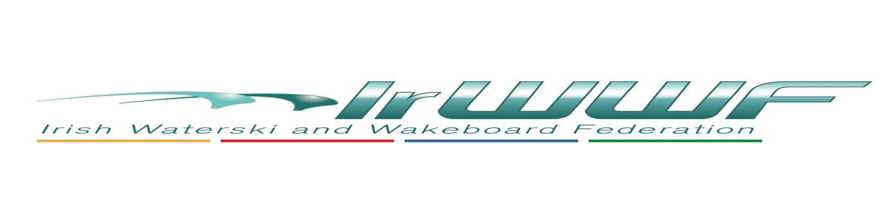
Disability Officer Report for AGM 2023 – Cormac Collins

Water sports Inclusion Games Report 2022
Lough Derg yacht club, Dromineer
W/E 24,25,26 June 2022.
Set up Friday & crew on Saturday; Paul Carroll, Andy Mc Quiggan , Cormac Collins.
Crew Sunday; Paul, Andy, Cormac along with David O’Caoimh & Cornelia Krausz.
Boat for w/e kindly provided by Tommy Whelen.
Fuel sponsorship organised by Dave Zebedee.
Carrig wake (presently resting) provided wet-suits,life jackets, skies, boards, ropes.
IrWWF provided both financial support & equipment like newly purchased Sit-ski.
LDYC provided a rescue boat, along with a great welcome & many cups of tea.
A Big Thanks To You All.
It was a weekend of very poor weather for water sports, with high winds & rough water.
A very successful outing on Saturday with Mark Henderson on a sit-ski.Mark is quadrapelic whose main sport is kayaking, which helped him greatly with balance on the sit-ski.
We had 2 small groups on Sunday, when both David & Connie did some boat coaching.

VISION SPORTS DAY
Saturday 10th September ,
Hosted by Wake N Ski in Summerhill Co Meath.
Manpower on the water was provided by Jeff Harney, Brian O Callaghan, Ellen Collins, Eamonn Prunty & Cormac Collins.
Manpower on land provided by Vision sport Ireland staff volunteering for the day.
Sponsorship for the event came from VSI & IRWWF.
6 visual impaired people of all ages skied, 2 for the 1st time.

Watersports inclusion games 2023.
Wexford sailing club
24th & 25th June.
Looking for some volunteers,
Looking for a ski boat based somewhere in South East area,
Contact made @ recent water Expo in Lisburn from Kieran McGuiness living in Wexford, who may be able to source a boat.

