Cianne Naji
1991 – 2013
Cianne was passionate about wakeboarding and about life. Having taken up wakeboarding at an early age she went on to win the ‘Open Women Division’ of the Irish National Championships in 2009 and subsequently competed on the Irish National Team in both European and World Championships.
Sadly, in January 2013, Cianne lost her life to Cystic Fibrosis at the age of only 21. In her honour, Cianne’s family presented a perpetual trophy to the IWWF to be awarded annually to the best up and coming female wakeboarder or water-skier under the age of 21.
The best tribute to Cianne is from her closest friend and professional wakeboarder, Nicola Butler, who describes Cianne and her passions far better than any attempt we might make. See below.

DEPTH OVER DISTANCE: A MEMOIR FOR CI

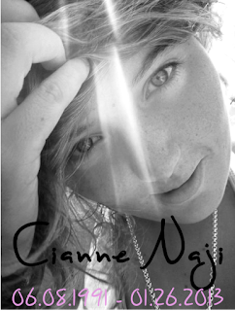

On January 26th, 2013, I lost one of the most important people in my life. My best friend and hero, Cianne Naji, lost her battle to Cystic Fibrosis, a critical and stupid lung disease. She was 21 years old. It is incredibly unfair that she was taken so young, but nobody can say that she didn't live her life to the absolute fullest.

I first met Cianne at Orlando Watersports Center the spring of 2007 when she was living in Orlando. Brought to the mecca by her love for wakeboarding, we had an instant connection. I met her at the tender and impressionable age of 15, and although she was only a year older than me, I couldn't have asked for a better mentor. I was in complete and total awe of her. I thought I was cool having lived on 3 different continents by the age of 15, but she already had me beat. She was so headstrong and worldly, and I was like a sponge soaking it all in trying to learn the ways of the world. She was so different from anyone I had ever met and anyone who has ever met her would agree. She is always buzzing with this energy that you can just sit in silence with her and be perfectly content. She had no regard for what other people thought about her and just lived her life exactly how she wanted to. That's a very rare thing to find in someone. She was as unique as they come. A couple of days after meeting Ci, she taught me how to drive. I had one of the best seasons of my career in 2008, my rookie year, and I bought a truck outright with cash. I can still picture the beaming smile on her face, and I knew that she was so proud of me. This also meant that I now had to drive 45 minutes out to Clermont to pick her up every day but I didn't care one bit. We decorated the roof with glow in the dark stars, and she covered my seat covers in sharpie with her amazing artwork. Shortly after obtaining my license, possibly even the day of, I drove into someone in a parking lot. I was so frightened, and she just said, “Get in the car,” and drove us to Walmart. She bought a hammer and some spray paint, and she tapped it out and covered it up, and we never said a word about it to anyone (sorry dad). This moment marked the beginning of what was going to be a long and beautiful friendship. The adventures that entailed that summer and the next few years were nothing short of amazing.

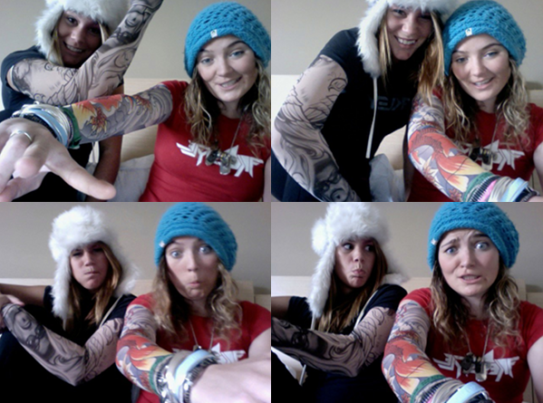

Cianne didn't like to talk about her Cystic Fibrosis because she didn't want this disease to define her. And it didn't. The life expectancy for CF patients is 35 and she was entirely aware that her days were numbered. If you had met her and she didn't tell you, you would have never known. Her passion and love for life and adventure was so contagious. In the last couple months, her lung function dropped to around 70% and she was admitted to the hospital more and more frequently. In 2010, we were out surfing in Spain and a big set came through, forcing us to paddle out to get over it. Ci just made it over and started to cough up blood, and as I stared at her in horror it dawned on me that my friend was really, really sick.
Cianne had always known that a transplant was not an option as she had MRSA. A bug she only contracted a couple years ago from poor hospital care. This also means that she could never actually meet another CF patient face to face, as she was too much of a risk to infecting them. I know that this saddened and frustrated her tremendously as there were some dark times when I couldn't be there for her. She just needed support from others going through the same thing and I couldn't be that. A couple years ago, she decided that she wasn't going to live her life a slave to the copious amounts of medication that this disease demands and she just stopped taking them. She wrote an excerpt for the Irish Times that you can read here. She told me that she knew her time on Earth was limited and she just wanted to go everywhere and do everything. To this day I remember this indescribable mixture of pride for my best friend's courage and this heart-wrenching pain of knowing the inevitable. I remember thinking that she was superhuman. No one can look death in the face that calmly and with so much positivity. I hugged her for a long time and vowed to help her achieve that and be by her side as much as possible. I thought we had so much more time, and so many more adventures planned but now you're gone and you didn't even make it to my 21st birthday.
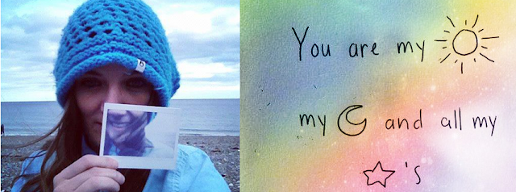

She was a fighter right until the end, and she went peacefully surrounded by her friends and family. I would have been there if I had known that it had gotten this bad, but that's another thing about Ci that tears my heart open - she was a natural protector. Even though she was the one in and out of hospital, going through chemotherapy, or undergoing complicated surgeries, she never let me know just how serious things were. Although she moved back to Ireland and our friendship was long distance we talked every day as if we had seen each other yesterday. ("No distance of place or lapse of time can lessen the friendship of those who are thoroughly persuaded of each other's worth.”) She would one day nonchalantly mention that her lung collapsed a few days ago and she was back in the hospital, and then move on to asking me how my contest went the past weekend or what's the next trick I wanted to learn. Since day one, she has pushed my riding and been one of my number one supporters. She was always the first to text me “Good Luck” before a contest or “YES BUTLER!!!” right after a win. She would stay up till ridiculous hours in the hospital to watch me ride online in a live contest, and I just love her so much for doing that and for being there for me. Her support knew no limits.
When she couldn't wakeboard anymore, I like to believe that she lived a little vicariously through my riding. It makes me so incredibly happy to know that I could have done that for her and been there in that way. To have someone believe in you so wholeheartedly like that makes life so worth living. She is one of the few people that I know that would drop absolutely everything for me. Time, matter, or money was not an issue. In fact she did do this for me in 2010 when I was going through a breakup and I needed her wise words and a shoulder to cry on. She said we are going on a surf trip, I'll meet you in Spain next week. You came all that way for me when you were so incredibly sick. And even though the weather was horrible and you contracted pneumonia, which meant we spent most of the week in the hospital, it was one of the best trips of my life. Her best quality was motivating people to reach their full potential - to become the best of their ability. She didn't take mediocre as an option for her short life, and she certainly wasn't going to let you.
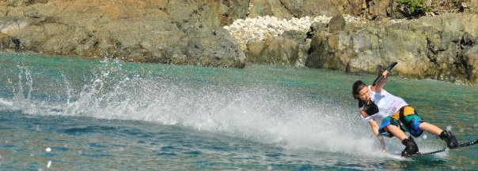

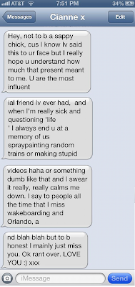

As her CF worsened, she wasn't able to ride and compete anymore which devastated her, but of course she found a way to turn the situation around. Last year she said, "I know I will never get back wakeboarding. I miss it every day. But it’s a case of better to have loved and lost than never to have loved at all." She saw the positive side to every situation no matter how grim, that's just how awesome she was. Shortly after this realization she started Breathe Boardwear, a unique line of stylish apparel and footwear for girls like her that have a love of boardsports. I am so proud of her for being the founder & designer of this amazing company that gives a percentage of proceeds to help others fighting CF. Her spirit will continue to shine on through Breathe and she has a whole army of Pro Female riders helping to push her vision. This was her way of staying connected to the sport and community that she loved and felt so passionately about. (Please go check out and support this amazing brand.)
On this note, I just want to highlight some of her achievements in the short, yet amazing, 21 years she spent on this planet. (I say some because this memoir would turn into a best-selling novel if I were to list them all.) She lived in Ireland, Switzerland, Amsterdam, Orlando, Morroco, and I wouldn't be surprised if you told me that at one time or another she had visited every single country on this planet. She spoke French, English, Arabic, and she went to Art College in Holland for a year and learned some Dutch. She was such a talented artist, and my shoes, car seats and arm's were her constant canvases. She was an Irish National wakeboard champ and placed 9th in the world in Korea in the last contest she ever competed in. She was the founder, director and designer at Breathe Boardwear and her legacy and vision will forever live on through her company. Most of all she was a beautiful, selfless, loyal, and loving friend to hundreds around the world. She accepted everyone without judgement and she always seemed to have a smile on her face. She was so funny and she made me laugh so much. The kind of laughter where we laughed so hard that our sides felt like they were splitting and we couldn't breathe. We mostly talked in a language of inside jokes, the familiar speech of two best friends with way too much in common. I'll miss her forever.

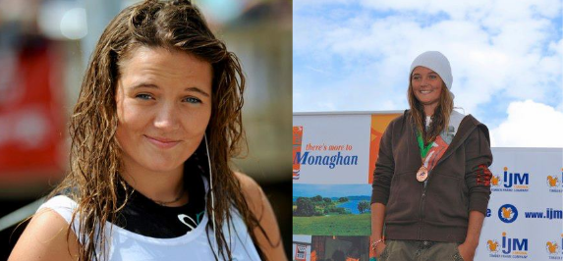

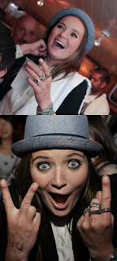

Her lovely mom, Orla, put together an amazing birthday party for her 21st last June, inviting all of her friends to come celebrate from all around the world. Unfortunately, this fell on the same date as a Pro Tour stop in the U.S. I had a ticket booked to come right after for a couple of days and then fly straight back to another contest. Looking back I wish I had missed that contest to be there for her. She was worth so much more than any contest. She told me that she had such an incredible time at her party and was so overwhelmed by all the tremendous amount of love for her. Unfortunately, she contracted pneumonia from the exhaustion of the party and was readmitted to the hospital shortly after. I still wanted to come and just lay in the hospital and watch movies with her but she wouldn't let me see her like that.

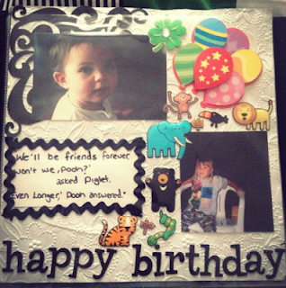
In July, I flew over to England for Wakestock, and we knew that we were so close that we had to see each other. She couldn't fly because of her lung capacity, so she drove over with a friend from Ireland. That was the last time I saw her, and I am so thankful that I got to give her my 21st birthday present - a scrapbook of all our photos and memories together.
I wish every day that I had another chance to see her and say goodbye formally, but then I think no, that's not how she would have wanted it. She would have wanted it exactly what it was: a weekend together where we were happy and free - a see you later, not a goodbye.
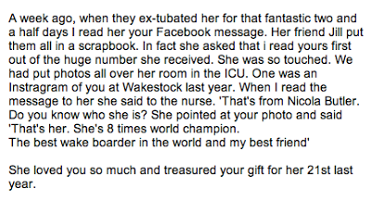
8 time world Champion!? 3 down 5 more to go for you, babe.
Cianne, you are so loved and you have inspired so many people to dream bigger. I miss you so much and whenever I want to give up on something I know that I have to persevere to make you proud. From here on out, it's all for you. You are tattooed on my arm and etched into my heart for the rest of my days. Your death will not be in vain and we will find a cure for CF so no one else has to lose their best friend. I know you are finally breathing easy up there and watching over me with all the other angels. Rest in peace, little wild one.
A fan just sent me the most beautiful message and said that 'she can watch over you from a whole new perspective now. Right by your side forever. Every time I see one of your competitions or one of your awesome wakeboarding videos from now on, I will see them differently. You've got an angel on your shoulder'. She is so right :) xo

