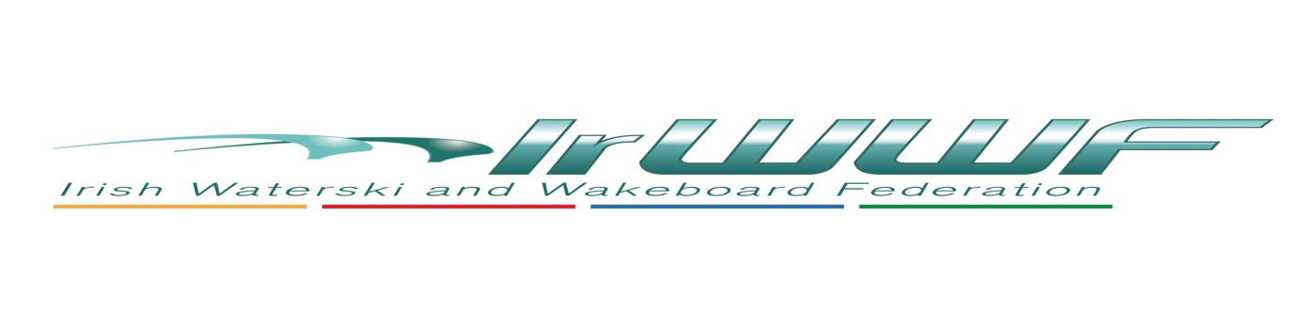
Wakeboard Officer – AGM Report 2023, David Zebedee

2022 Finally saw the lifting of Covid restrictions enabling the season to get under way,
first up was the Wakeboard boat nationals held at the Newferry Club 10/11 June this was an amazing event as not only did all the usuals show up we had a couple of new competitors in the under 14s .
Practice was held on the Friday with the event been held on the Saturday.
A G23 was supplied courtesy of Gary McClintock, my thanks to him.
The event and the support by local business made this a fun event as all catering, fuel and entries were covered by different levels of sponsorship. The committee of Newferry did an outstanding job and hopefully we can experience it again in 2023 subject to dates .

July was a busy month on the World Stage with the World Games in Birmingham Alabama were held from the 13th to 16t July. With only two Irish riders meeting the criteria for invitation it was left to Nicole Carroll to Represent Ireland as David O’Caoimh had work commitments and couldn’t attend.

The World games is an Invite only event and Nicole was among the top 11 Classed Female Riders in the World who were invited, Whilst Nicole didn’t place she rode well and did herself and Ireland Proud.

The World Boat wakeboarding Championships were held in Lago de Salto, Rieti, Italy. 25/7/2022/-30/07/2022. This was a stunning location with amazing facilities beach, bar, cafes and an outdoor pool. The only issue was the changing wind directions .

Ireland was represented by Peter Stewart , David Coates , Nicole Carroll and Julian Zebedee . Unfortunately David O’Caoimh couldn’t compete due to work commitments but was there for a few days to encourage the team. The team were well supported as it was a real family affair, the Stuarts, the Coates, the Zebedee’s and the President .

At the start of the week conditions were really good in the morning but the wind seem to get up in the afternoon presenting some challenges to the riders.

Julian Zebedee moved into junior men this year a really tough category but managed to get through to the quarter finals.
Nicole went well in her heat and narrowly missed out on getting through to Qtrs.
David and Peter sailed through their heats to the Final of Master Men, however the conditions changed as their final commenced making the water extremely choppy but they did finish 4th and 5th. A great result considering the amount of time they had on the water prior to the event and conditions on the day. Overall a good result for the team .

The Team finished 12th overall out of 22 Countries, not bad for a four person team.

Let’s not forget our own Linda Johnston, Linda was Chief Calculator at the event and was cheering our Riders on as usual. Well done Linda.

The European Championships were held in Fuhlinger-see 8-13 August 2022 in Germany.
We had one competitor compete Paul Johnson in the Masters Men category . Paul did us proud bringing home the gold medal. Well done Paul

Cable Wakeboard
As we now only have one Cable park in Roi Ballyhass was very busy as with schools and corporate outings however they did hold the Ballyhass Open, according to Eoghan this was a great success with 40 % of the riders coming from the North. In all he reckons there was 45 riders of all ages .

2023
Irish Wakeboard nationals provisionally Newferry subject to dates and tender
Europeans, date to be announced possibly Belgium.
Worlds, date to be announced possibly Thailand.

Ballyhass
Eoghan has several events planned this year :The Celt Wake event, this is a competition for students in colleges accommodation may be a problem so undecided at this time .
Couch to Kicker program , 6 week program women only. Teaching women how to wakeboard probably end of June.
Irish Nationals pencilled in for August.
Ballyhass Open pencilled in for Sept.

