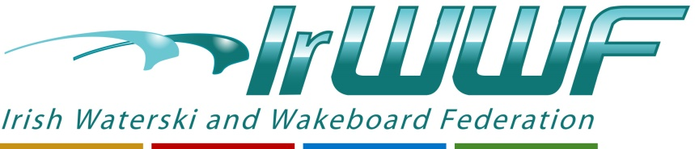

Final Result
U14 Girls
- Zara Conely
U14 Boys
- Jack Gamble
Junior Men
1. Julian Zebedee
2. Sam Mc Clintock
3. Thomas Muir
Masters Men
- David Coates
- Peter Stewart
- Paul Johnston
- Thijs Van Rosmalen
- Jose Del Castillo
Open Ladies
1. Nicole Carroll
2. Aisling Deegan
3. Alice Murray
4.Maria Del Castillo

Open Men
1. David O’Caoimh
2. Ashley Murray
3. Ross Flemming

