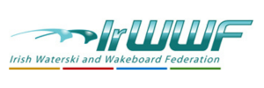

AGM 9TH MARCH 2024 CLAYTON HOTEL DUBLIN AIRPORT
AGENDA
- Welcome and Apologies
- Approval of Minutes of the AGM of 25th March 2023
- President`s Report
- Secretary`s Report
- Treasurer`s Report
- Waterski Report & Development Officer Report
- Wakeboard & Cable Report
- WIS Officer Report
- Anti-doping Report
- Safeguarding Officer Report
- Agree Affiliation Fees 2024/2025
- Governance
- Competition Calendar 2024
- Election of Management Committee
- Any Other Business.
- Meeting Closed

- Awards Ceremony
1/ Richard Armstrong Memorial Trust Award 2023.
2/ Cianne Naji 2023 Award.
3/ Irwwf Young Sports Person of the Year 2023.

