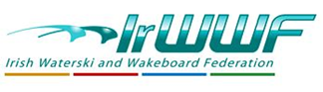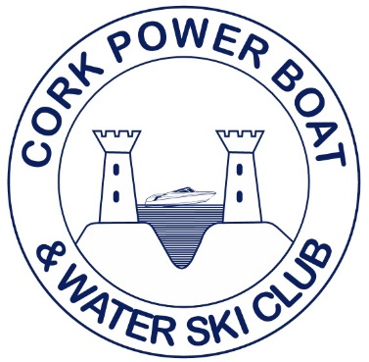
Irish National Waterski Championships 2022
Slalom Results

Under 17 Men
Marcus Cullen 1st U17 Men 4 @ 52kph 18m
Open Men
Daniel Galvin 1st Open Men 5.5 @ 58kph 12m
Jake Bridges 2nd Open Men 2.5 @ 58kph 13m
Open Ladies
Mary Angland 1st Open Ladies 2.5 @ 55kph 18m
Eileen Galvin 2nd Open ladies 5.5 @ Start 18m
+35 Men
Paurig O’Regan 1st +35 Men 1.5 @ 49kph 18m
+45 Men
Barry Galvin 1st +45 Men 2.5@ 55kph 13m
+55 Men
Rodney Watson 1st +55 Men 1@ 55kph 11m (Pending Irish Record)
Simon Durham 2nd +55 Men 3@49kph 18m
+70 Men
Arthur Murphy 1st +70 Men 4@ 52kph 18m (Pending Irish Record)
Division 3
Susi Fitzpatrick 1st Division 3 6@46kph 18m
Rebecca Perrott 2nd Division 3 6@43kph 18m
Jodie McCabe 3rd Division 3 4@Start 18m

