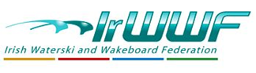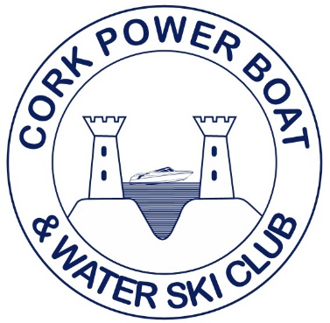
Irish National Waterski Championships 2022
Trick Results

Open Men
Daniel Galvin 1st Open Men 4140

+45 Men
Barry Galvin 1st +45 Men 960

Open Ladies
Eileen Galvin 1st 660
Mary Angland 2nd 360

