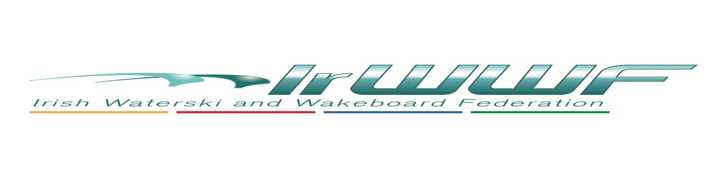
Waterski Officer – AGM Report 2023, Simon Durham

2022, Covid restrictions fully removed allowing all clubs to return to normal activity. It is worth pointing out most Clubs feel the skiing numbers have not returned to pre covid levels. This is something that needs to be watched .

It was great to see the Slalom league return and all clubs get involved, this competition has proved to be very popular and we want to develop better for 2023, allowing for an early competition calendar of event for the season.

Nationals run in Cork, so once again a big thank you to all the Galvin’s, a huge amount of work goes on to run and stage these events .

Europeans in France where we had Barry, Eileen, Graham, Mary and Dianne all competing on the international stage .

Competitions run In Meteor, Cork Power boat, Wake N ski and Golden falls throughout 2022. We would like to put on record our appreciation and thanks to the clubs and members.

2023 Objectives:

Increase overall standard and participation in Skiing.

Get more competitions running .

Look at ways to encourage all and where possible reduce costs.

Investment/fund for Clubs to develop on site, i.e. Homologation of all ski sites, correct buoys.

Review Insurance costs.

Encourage coaching and Driving.

I would like to take this opportunity to highlight the work that is undertaken by the committee and a huge thank you to Cathal, Brid, Dave Foley, Dave Zebedee, Keela, Miriam, Connie and Paul.

