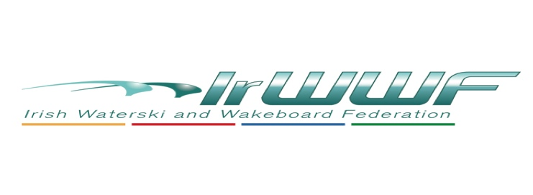
Women In Sport Officer – AGM Report 2023, Keela O’Malley

I took up the Women in Sport (WIS) Officer role August 2022 and in brief wish to report the following:
- 8 Clubs funded to run women in sport focused events; I want to commend the clubs for very new and innovative ideas. Social campaign ran in December 2022 links below:

Ballyhass Wakepark | https://sway.office.com/svZrE844MtMCID3n?ref=Link
Cork CPBWSC | https://sway.office.com/IbtKtDu2P3lfBQnr?ref=Link
Golden Falls Water-ski Club | https://sway.office.com/vLXt9a4gCmv8mpxH?ref=Link
Long Island Water Ski Club | https://sway.office.com/CwfFlV4KiDDxVleJ?ref=Link
Wake N Ski HERS | https://sway.office.com/ZVabOZDUymZyYZWD?ref=Link
Lower Bann Watersports Club | https://sway.office.com/tb0pdLuZWT9j4pX6?ref=Link
Meteor Water-ski Club | https://sway.office.com/OVdBCirV2fyE2ILo?ref=Link
Newferry | https://sway.office.com/lidRhfy3h61HMHzf?ref=Link

- Successful Her outdoors events funded in 5 clubs; images and reports provided.
- All females entrants to Waterski Nationals fully funded.
- All female who applied for IrWWF licence were refunded (22).
- 4 females funded for international competitions (2 of whom attended two events).
- Coaching level 0 course provided early 2022.
- Stronger presence and engagement on our social media; earlier in the year Cornelia Krausz designed new logo for our group.
- Introduced new standardised online application forms for funding WIS events in 2023 & appeal to all clubs for new WIS reps.
- Some WIS funds carried forward to 2023 with the permission of Sports Ireland.
- Federation now ranked number 8 for “Women on the Board” out of 65 federations registered with SI (Sport Ireland).
Attachment 1 is a summary of the last 2 years finances.

Currently in progress:
- Using Teams to centralise WIS data and collaborate with other officers (Involvement with IT subcommittee).
- Plans after AGM to contact all the new WIS reps to request that they be actively involved in WIS subcommittee.
- Very keen to focus on providing coaching, driving and officiating training for more women in 2023.
- Intend to move to using Spond app for communications with subcommittee and if required with clubs/members.
- Recently submitted 2 year finance report to Sport Ireland as part of our application for funding 2023/2024.
- WIS Officer has made an application to attend SI Leadership course commencing next month.
- Attended HER mover launch campaign during SI Ladies week and made good contacts with SI & other sport organisation personnel which will be contacted to expand our endeavours and to explore more opportunities that are available.
- Additionally a very interesting interview by Cornelia Krausz with Dianne Kirby was uploaded to all fed social media on International Women’s day.
- Believe there are other interesting and new ideas that can be developed this year by the subcommittee.

I would like to say a big thank you to the following:
- The clubs who ran events, provided me with images and reports
- My WIS subcommittee reps who have been encouraging and understanding in this time of transition
- The IrWWF Management committee for all their help and support

Attachment 1

2021 Finance Summary Report
Income:
(Note: some finances carried forward from 2019 & 2020) | €
15k Sport Ireland WIS grant | 15,000.00
Total income: | 15,000.00

Expenditure:
 | €
Refund of female licences (2020 & 2021) | 660.00
2 Females Leadership Course fees | 1,500.00
Cork Club ran training, competitions and events | 4,218.00
New female only trophies purchased | 1,225.00
Meteor club female days & competitions | 822.40
Newferry club female days & competitions | 400.00
Wake N Ski club female days & competitions | 1,425.00
 | 10,250.40

Total income 2021 | 15,000.00
Total expenditure 2021 | 10,250.40
Carried forward to 2022 | 4,749.60

2022 Finance Summary Report – subject to Audit

Income:
 | €
Carried forward from 2021 | 9,866.00
15k Sport Ireland WIS grant | 15,000.00
HERS outdoors grant | 2,500.00
Refund for slalom league division long line trophy | 245.00
Total income: | 27,611.00

Expenditure:
 | €
Club run event- Ballyhass | 1,500.00
Club run event - Cork | 3,150.00
Club run event - Golden Falls | 2,000.00
Club run event - Long Island | 970.00
Club run event - Wake N Ski | 3,000.00
Club run event - Lower Bann | 2,000.00
Club run event - Meteor | 2,000.00
Club run event - Newferry | 950.00
Competition licence refunds | 470.00
Misc. (trophies & merch €429 and Linda Johnson- chief calculator/official partial refund for travel expenses) | 687.00
International Travel for competitions | 5,788.98
 | 22,515.98

Total income 2022 | 27,611.00
Total expenditure 2022 | 22,515.98
Carried forward to 2023 | 5,095.02

